
Semesters Are Ending.
It’s Time for Rest and Reflection.
TESOL Has the Ideal Books to Help.English Language Teacher Development Series
Thomas S. C. Farrell, series editor
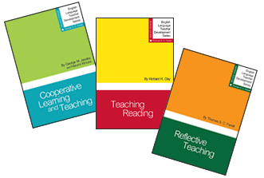
Short • Practical • Interactive • 15 Individual Topics
Buy Them All—20% OFF purchase of 3 or more
Dr. Farrell is renowned for his work around the world in reflective practice and language teacher education and development. His vision for the ELTD Series was to present a theory-to-practice approach in a set of short resource books written in a jargon-free and accessible manner for all types of teachers of English (native and nonnative speakers of English, experienced and novice teachers). Each affordable book offers a variety of practical methods and time for reflections that allow teachers to interact with the materials presented.
Toll Free: 888-981-0041
E-mail: tesol@brightkey.net

